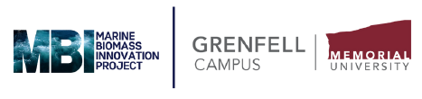
Student Research Assistant
Job Opportunity with MBI
Marine Biomass Innovation (MBI) project invites applications for Spring 2026 (June-August). Applicants must currently be enrolled in studies or have been accepted to study at Memorial University beginning September 2026.
Interested applicants should submit a cover letter and CV (Including two references) to:
Dr. William Newell Email: r34wjn@mun.ca
Dr. Kelly Vodden Email: mbi@mun.ca
Application Deadline: June 17th, 2026 (before midnight)

This part-time position is for a total of 40 hours at $19/hour from June to August 10th (Spring semester).
Successful candidates will assist a PhD researcher with a variety of data collection duties including photocopying, data input, and supporting the installation of meetings at local town halls.
Desk Work and Computer Duties:
- Co-create, photocopy and display advertisement posters and flyers for town meetings
- Photocopy Information letters, consent forms, agendas, posters, and other relevant material
- Data input, transcribing, and computer support
- Support Researcher during town focus groups and interviews
- Greet and Meet participants at town halls
- Display food and beverages
- Set up and take down tables and chairs at community events and workshops
Qualifications, Skills, and Experience:
- Experience working independently and with community members
- Solid computer skills in Canva, Excel, Microsoft, and the ability to conduct meetings online
- Strong attention to detail
- Ability to prioritize tasks, manage multiple responsibilities, and meet deadlines
- Willingness to work flexible hours, including evenings and weekends
- Ability to perform physical/manual tasks, such as setting up chairs/tables

